**SQL Querry**

Find title of each film.

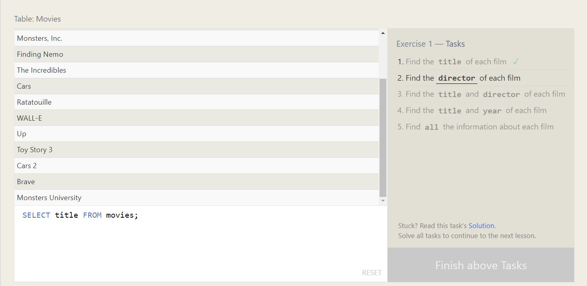

Find director of each film.

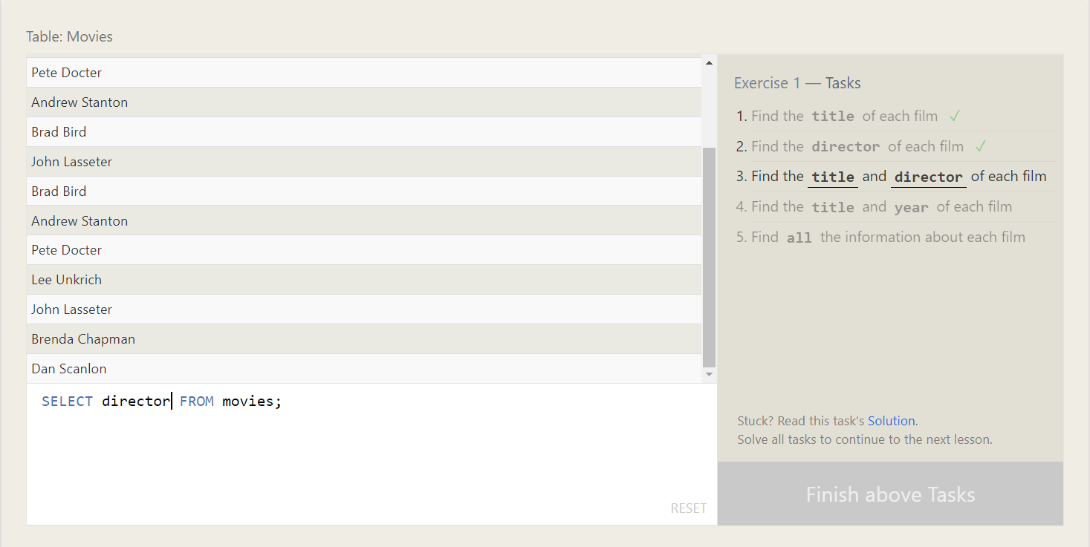

Find the title and director of each film.

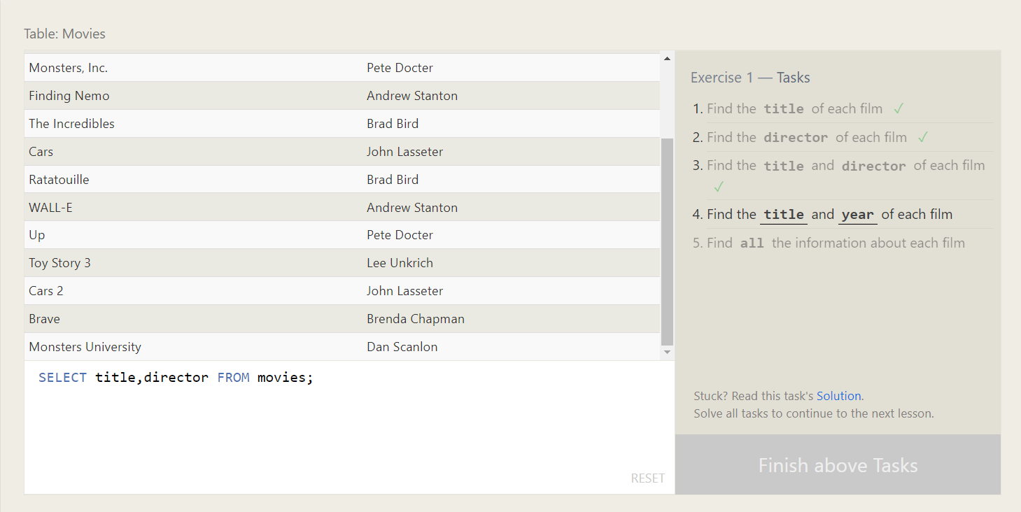

Find the title and year of each film.

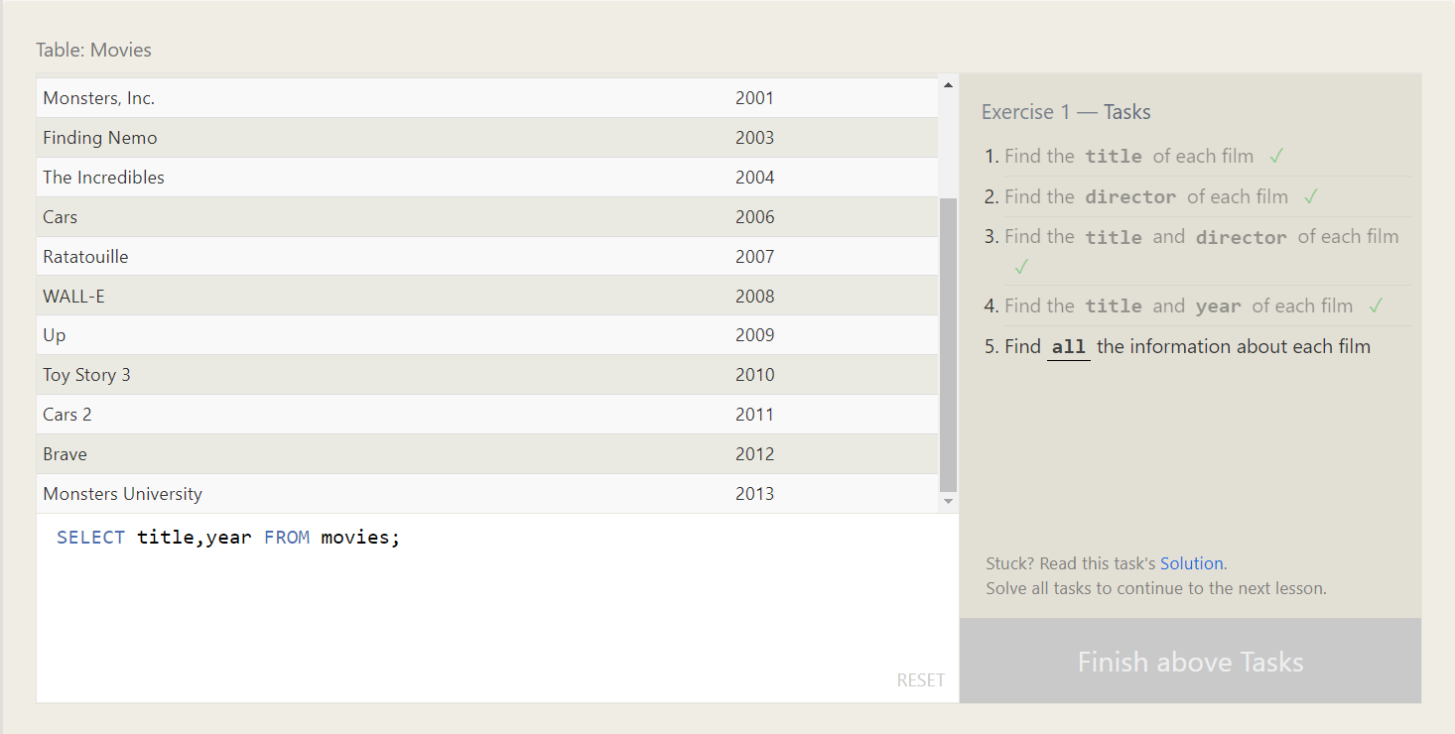

Find all information about each film.

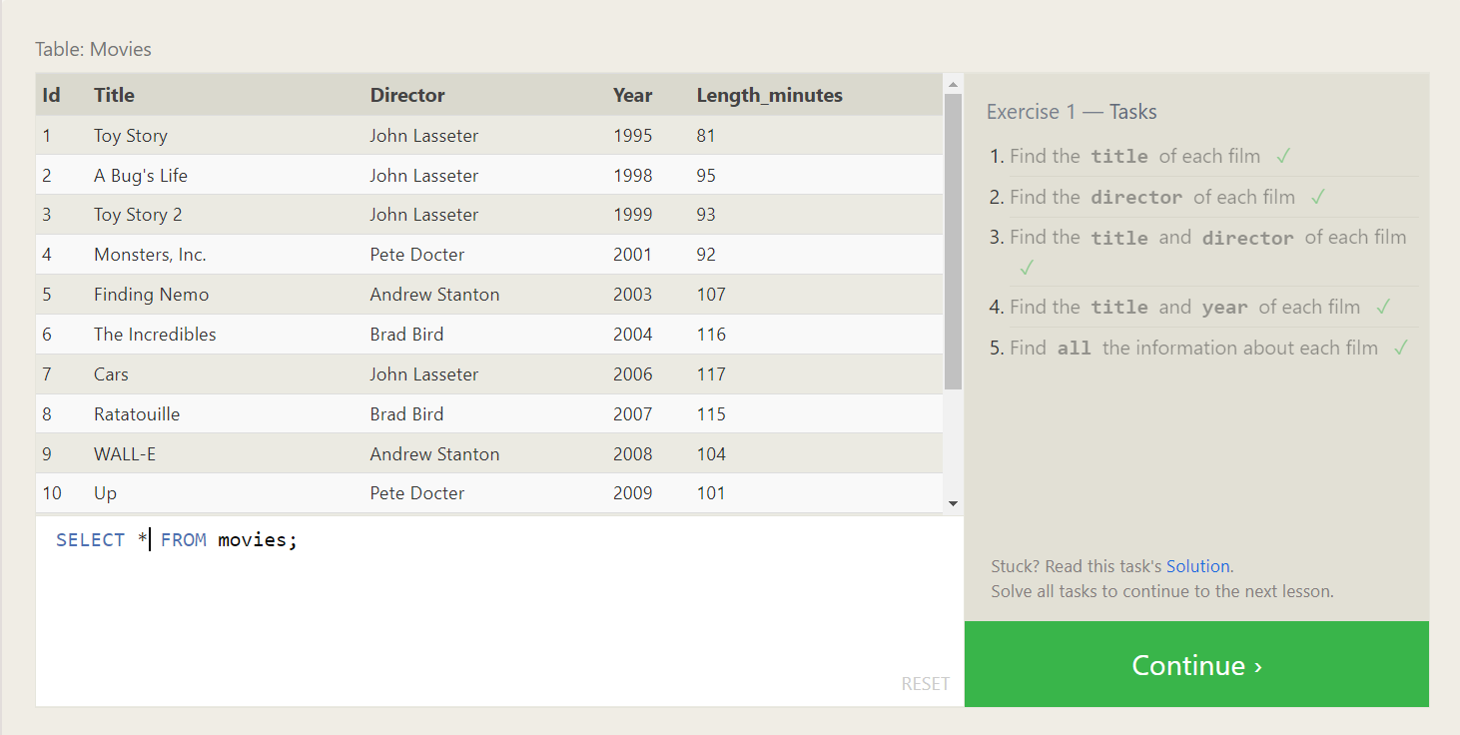

Find movie detail where Id is 6.

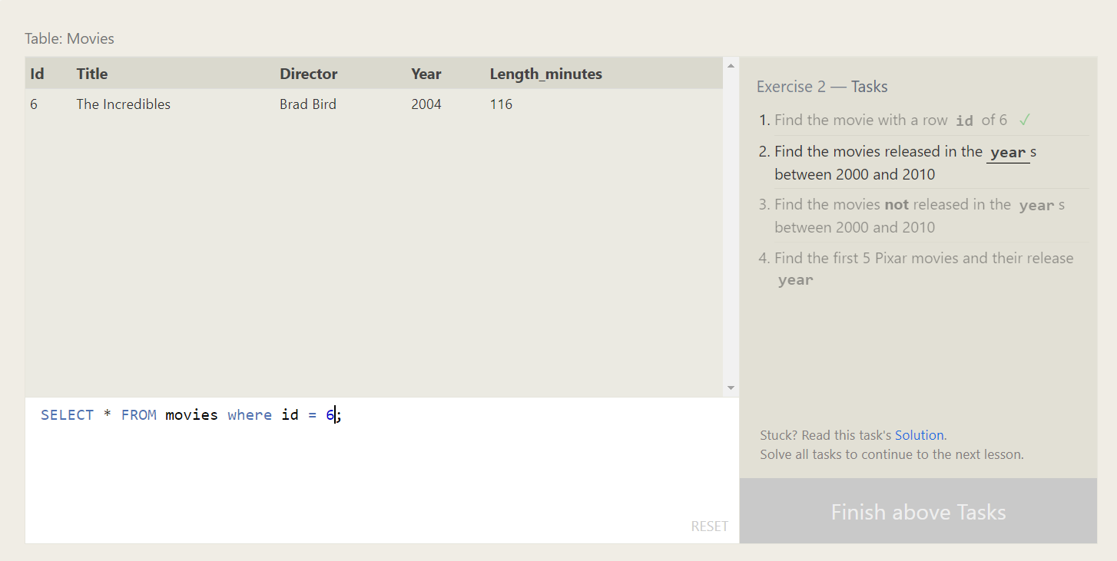

Find movies between years 2000 and 2010.

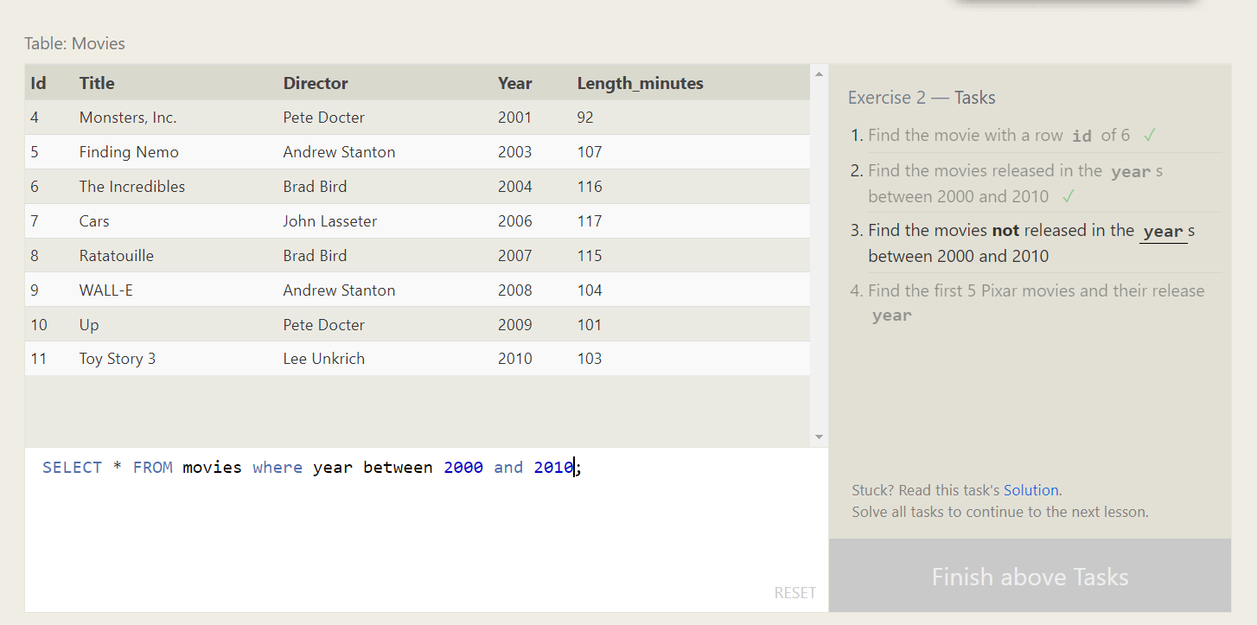

Find movies not released between years 2000 to 2010.

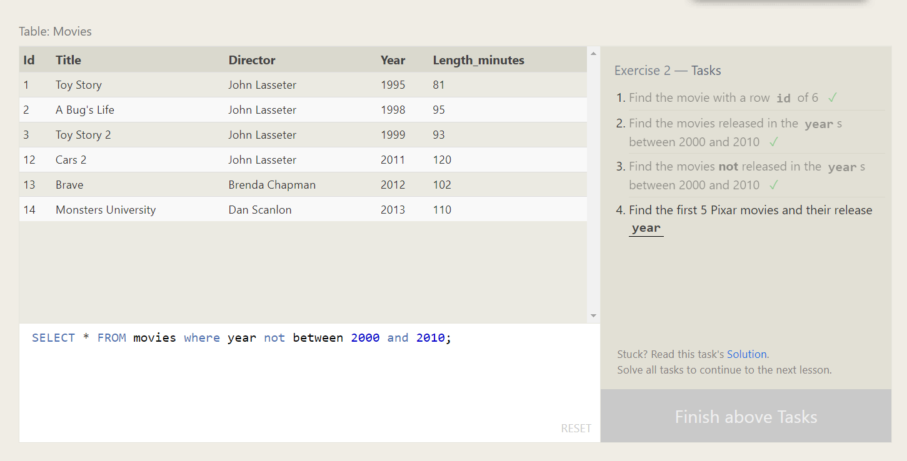

Find the first 5 Pixar movies and their release year.

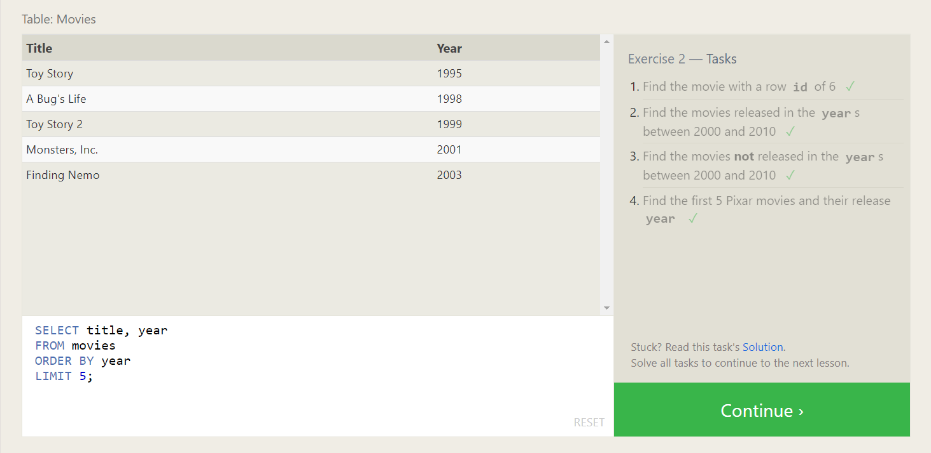

Find all toy story movie.

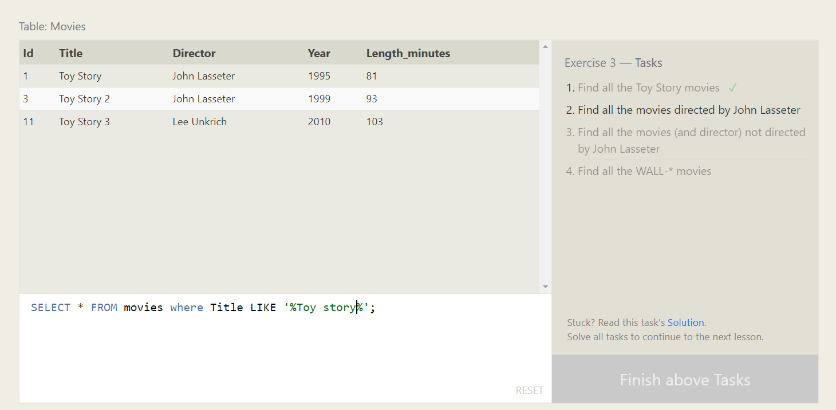

Findal movies directed by John Lasseter

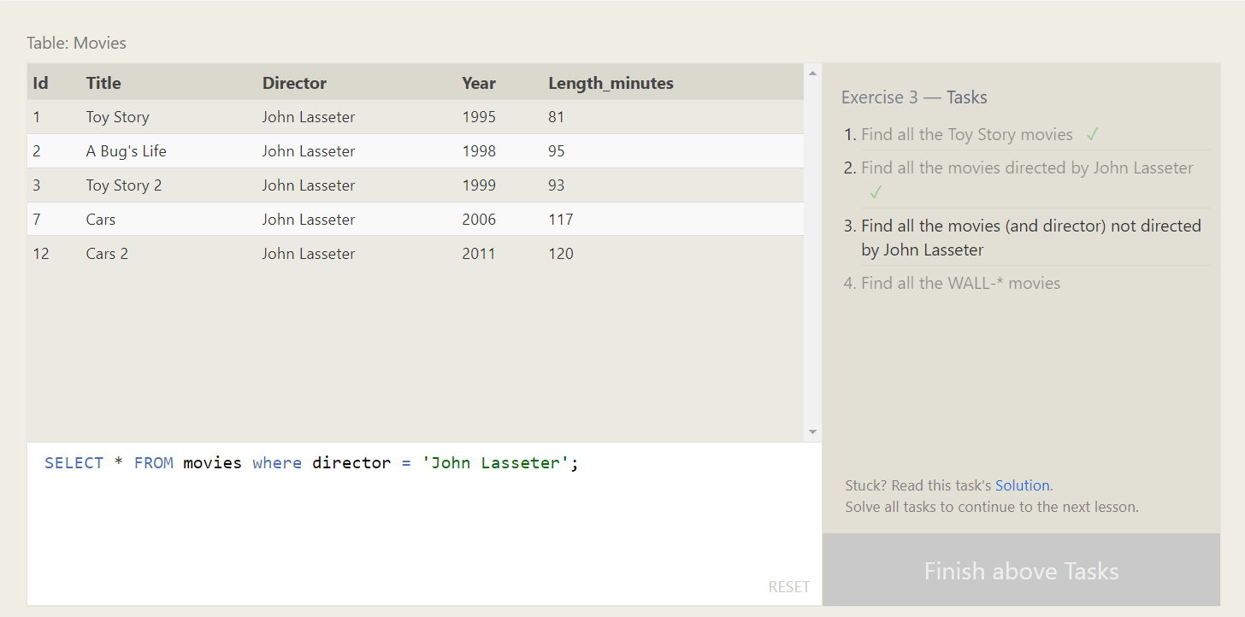

Find all movies not directed by John Lasseter.

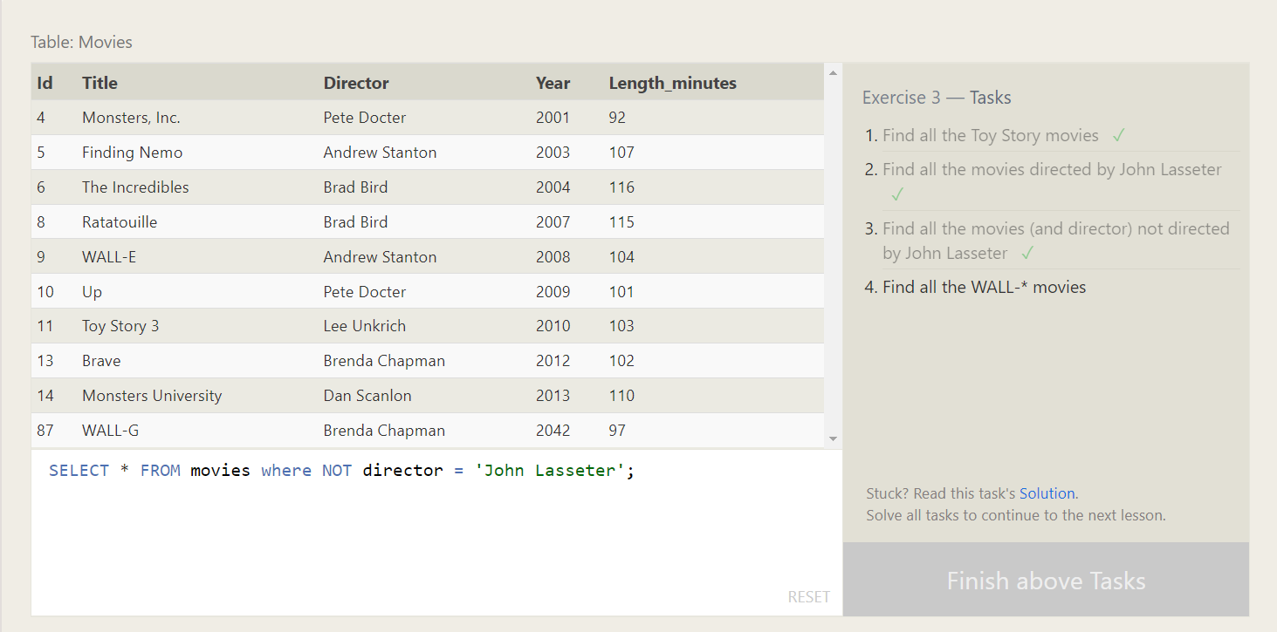

Find all the WALL-* movies

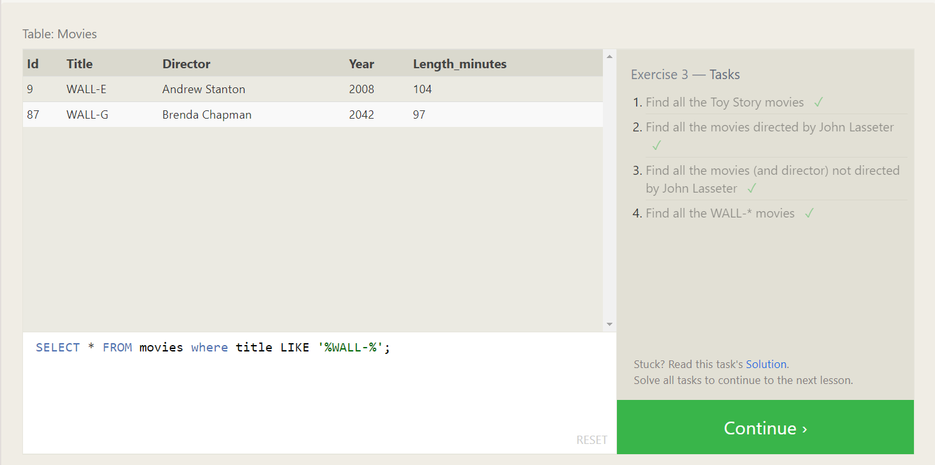

List all directors of Pixar movies (alphabetically), without duplicates

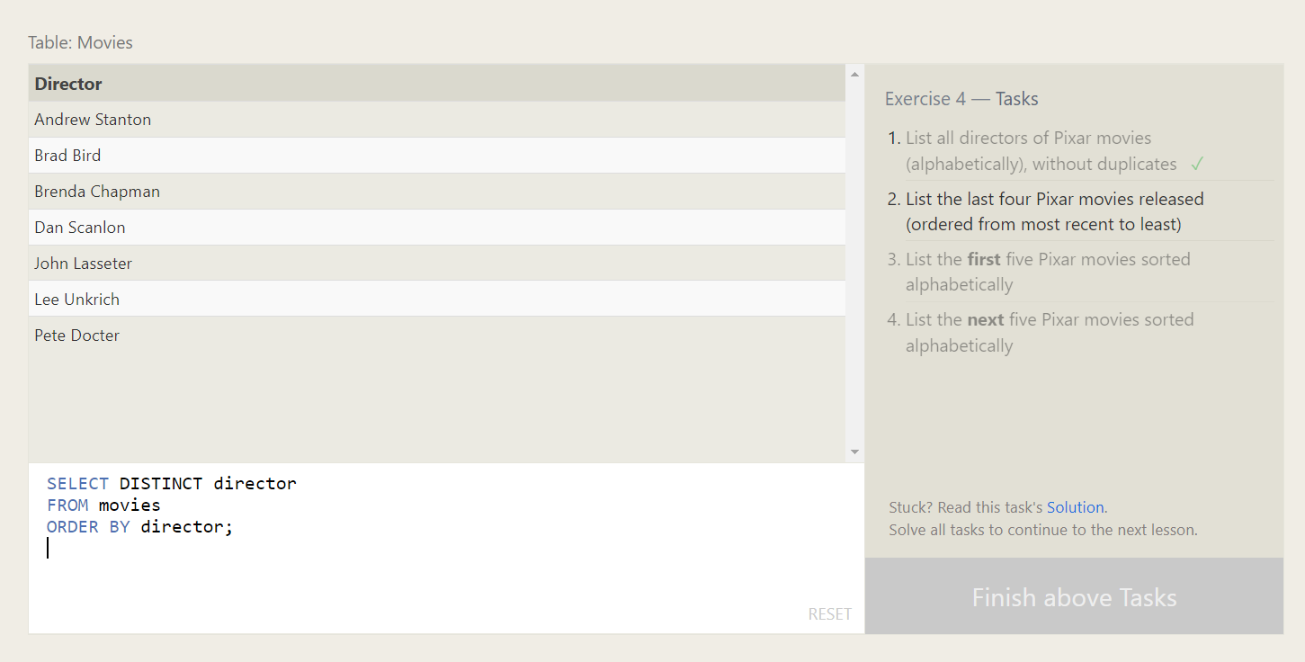

List the last four Pixar movies released (ordered from most recent to least)

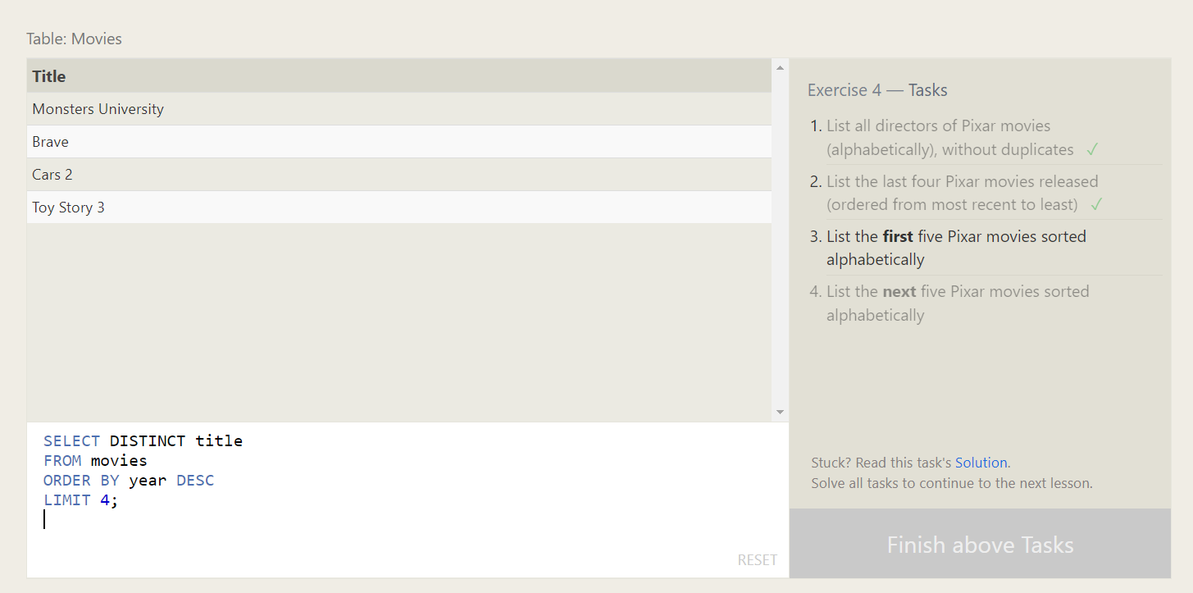

List the **first** five Pixar movies sorted alphabetically

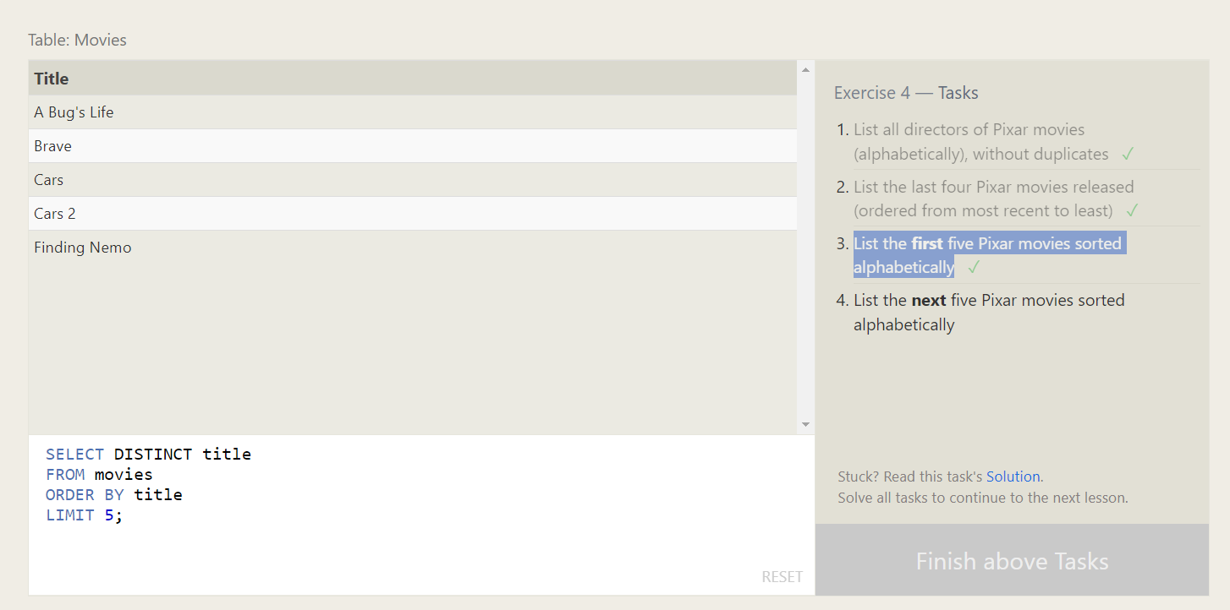

List the **next** five Pixar movies sorted alphabetically

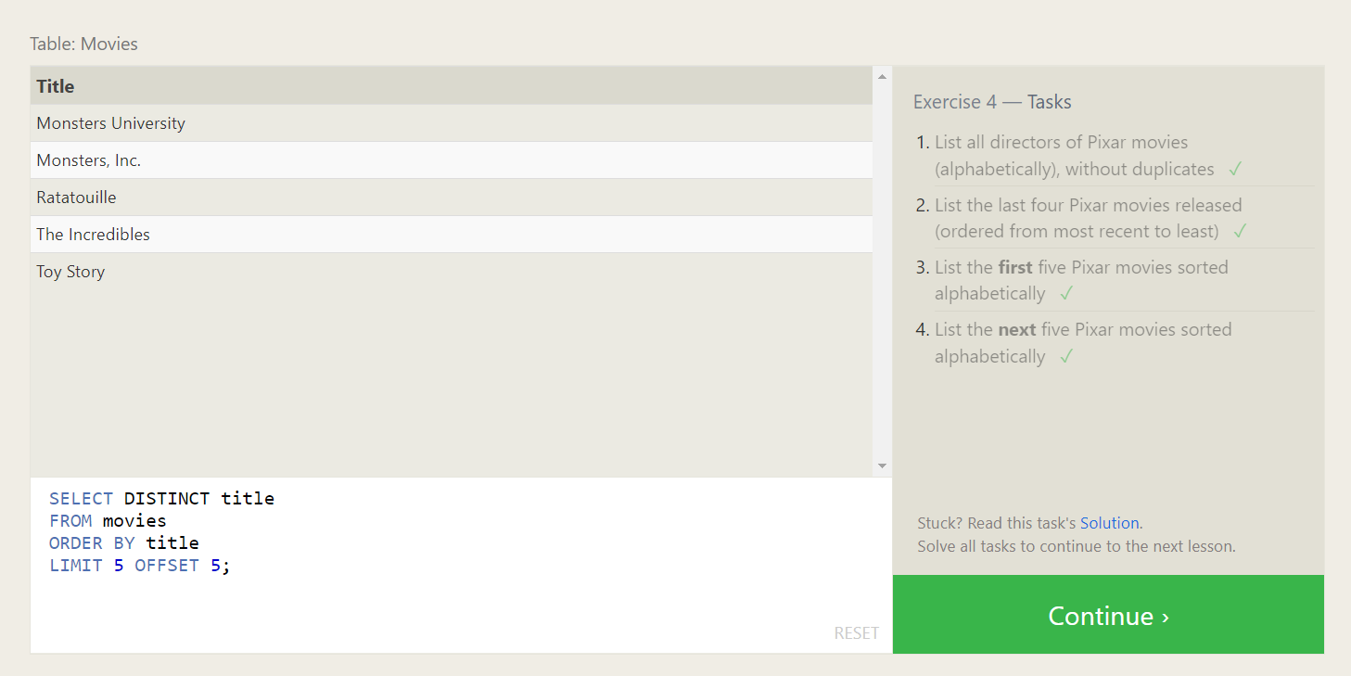

List all the Canadian cities and their populations.

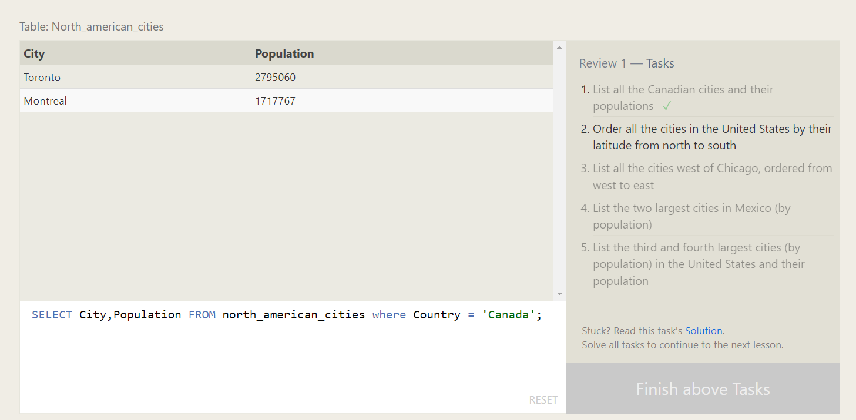

Order all the cities in the United States by their latitude from north to south.

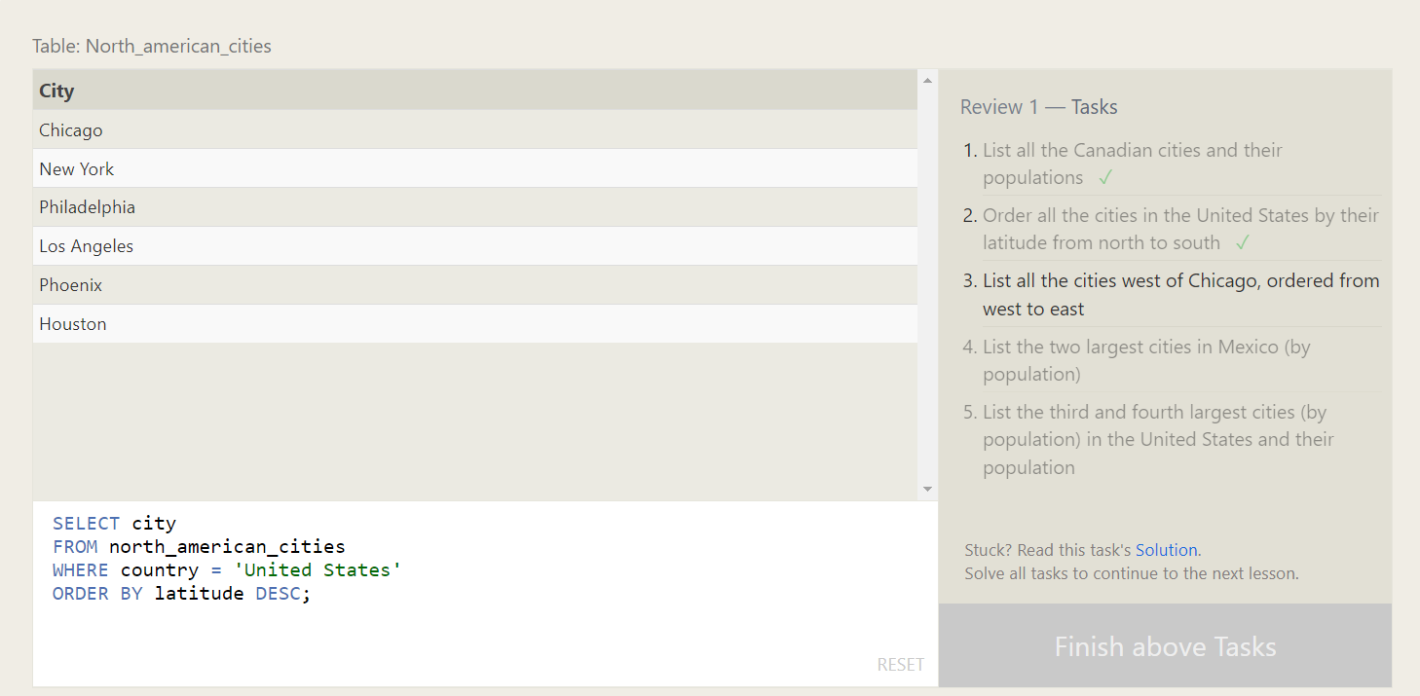

List all the cities west of Chicago, ordered from west to east

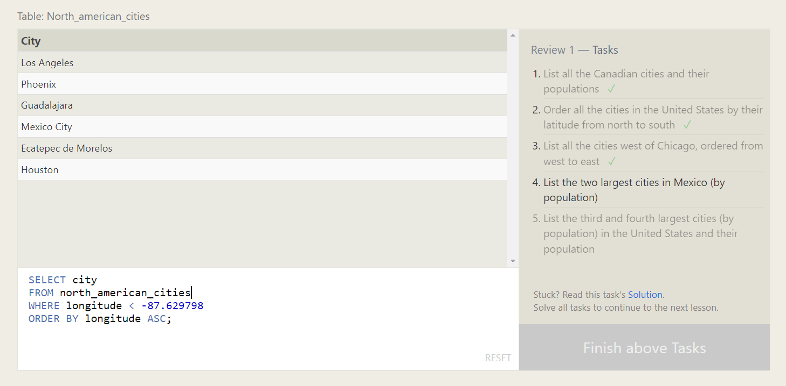

List the two largest cities in Mexico (by population).

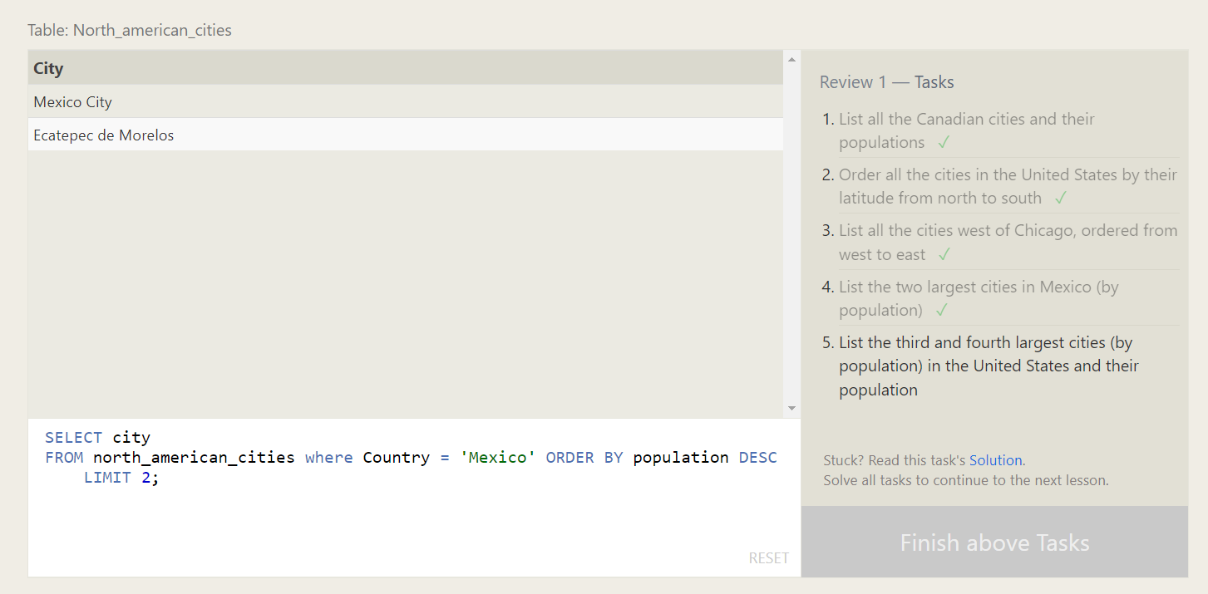

List the third and fourth largest cities (by population) in the United States and their population

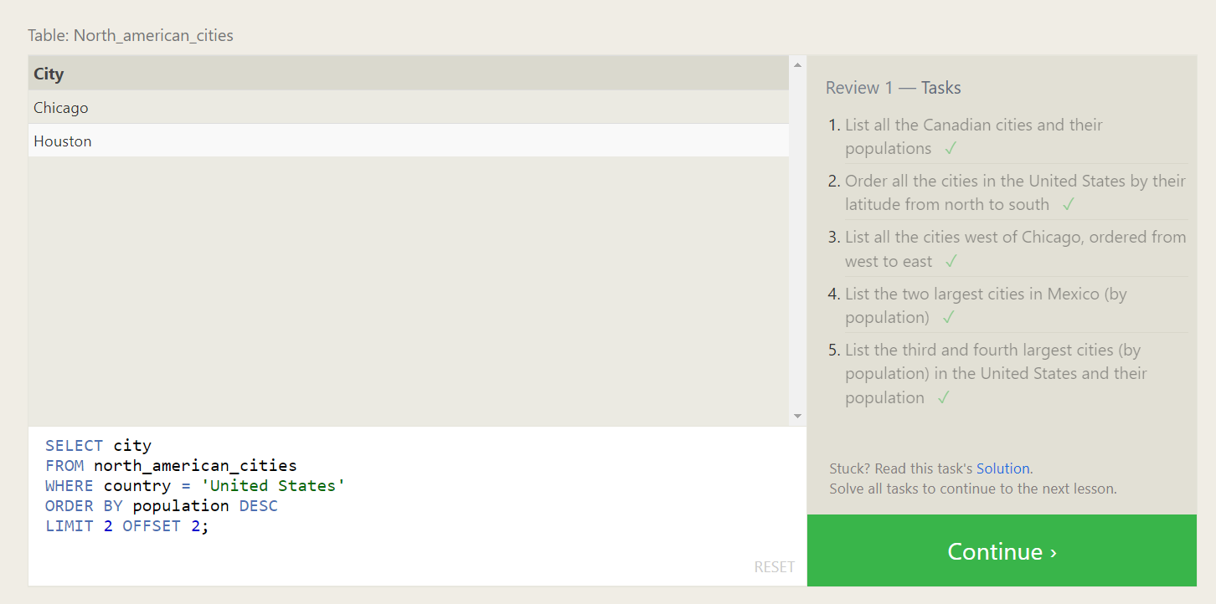

Find the domestic and international sales for each movie

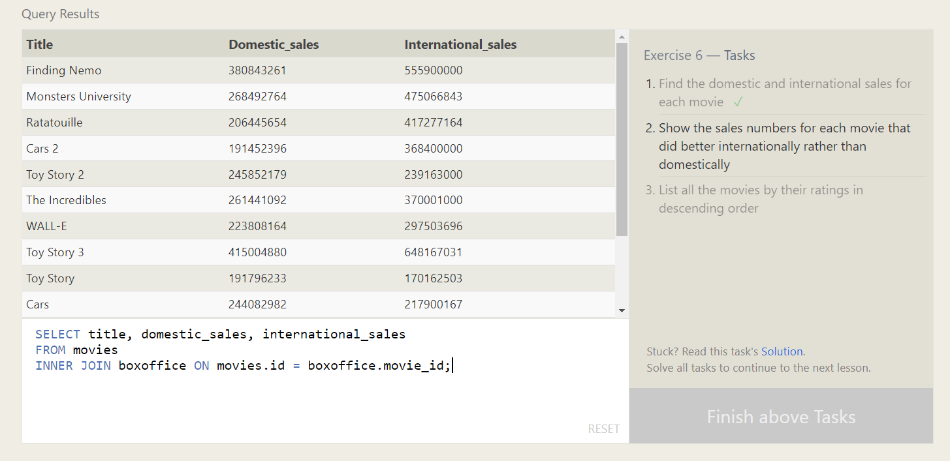

Show the sales numbers for each movie that did better internationally rather than domestically

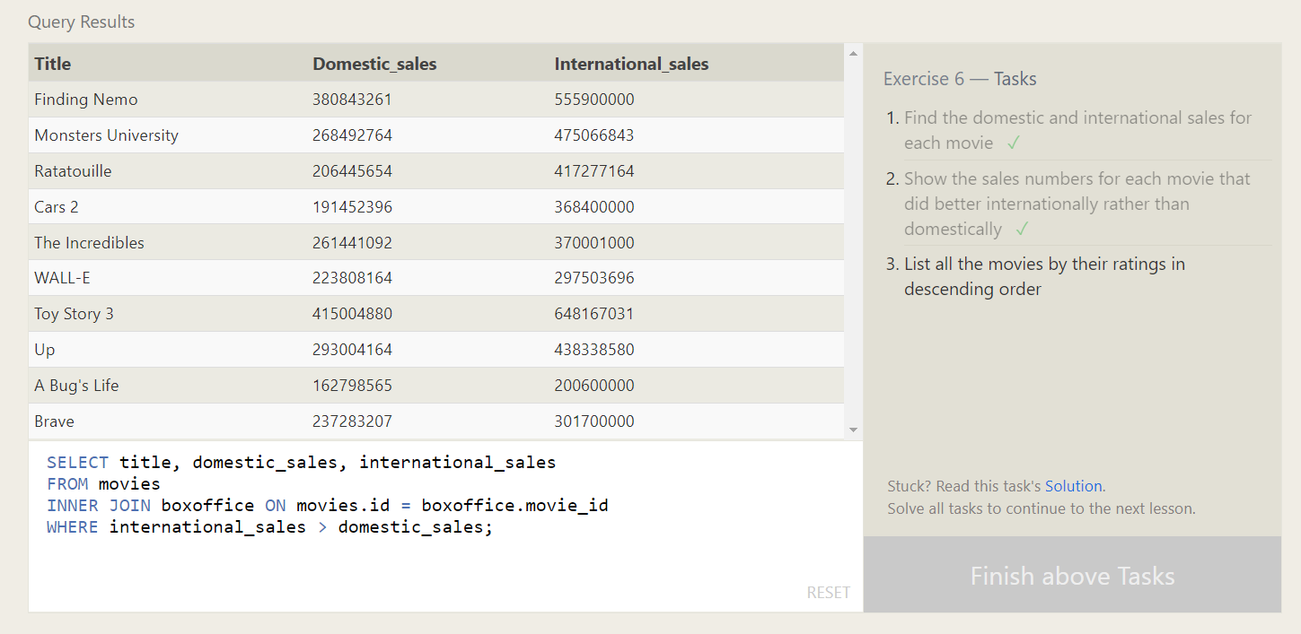

List all the movies by their ratings in descending order

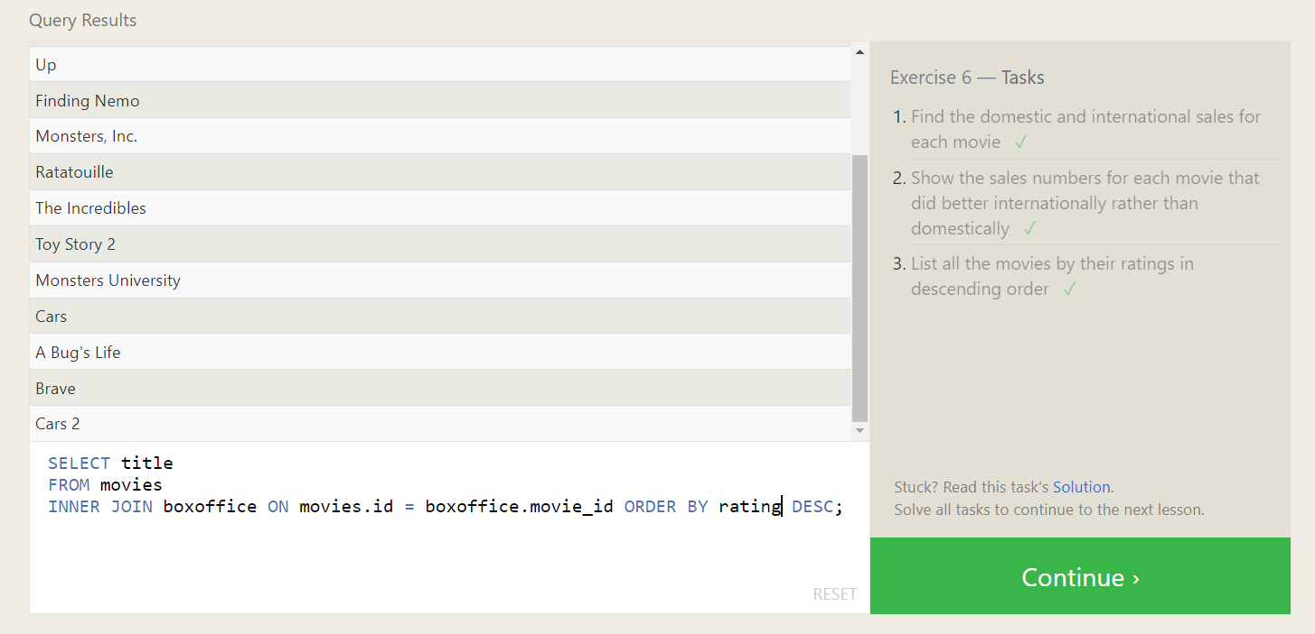

Find the list of all buildings that have employees

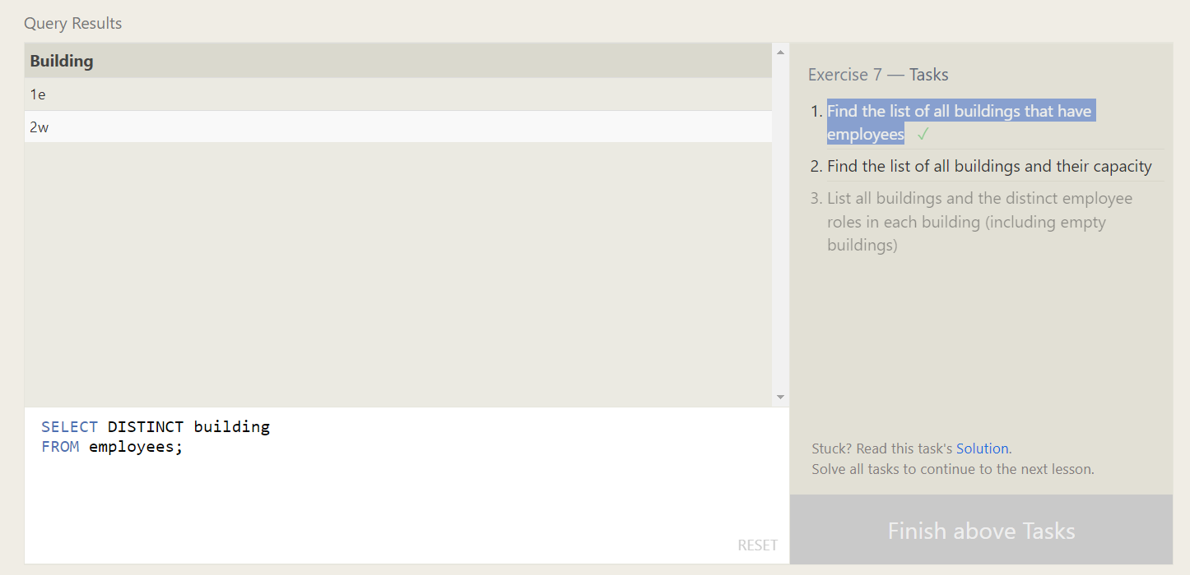

Find the list of all buildings and their capacity

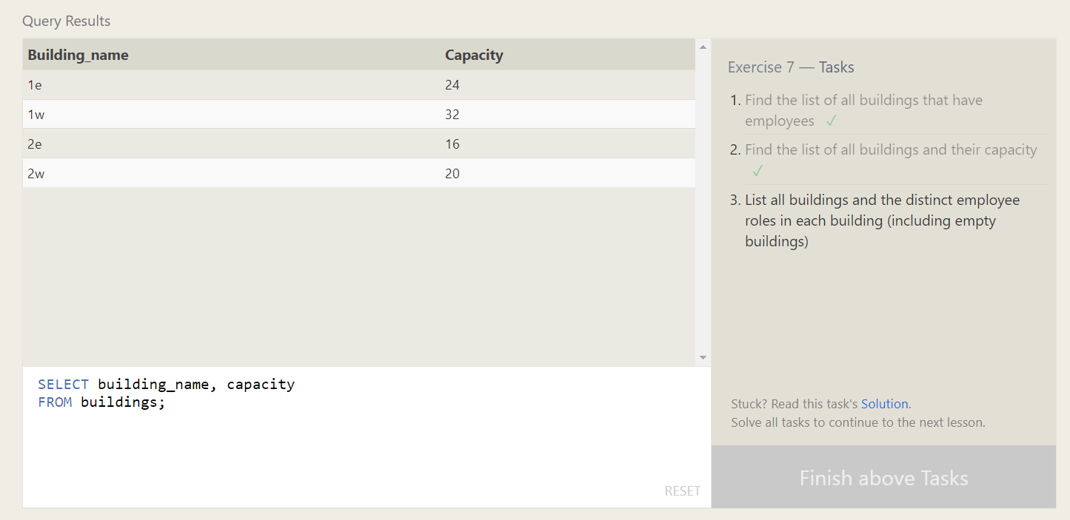

List all buildings and the distinct employee roles in each building (including empty buildings)

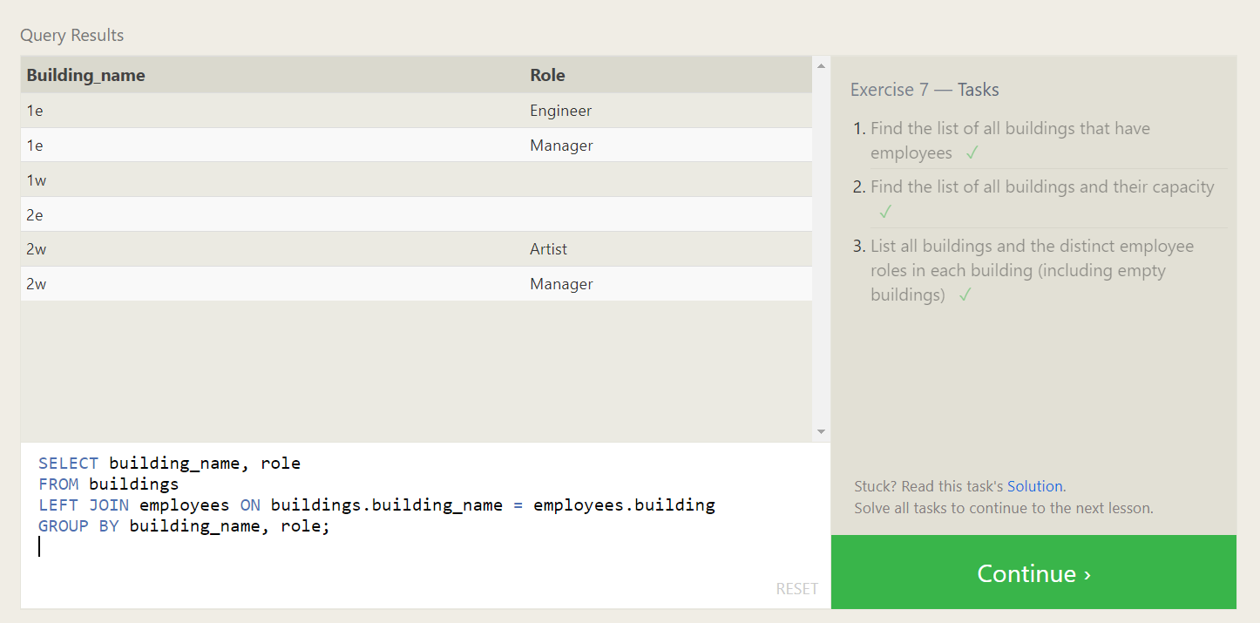

Find the name and role of all employees who have not been assigned to a building

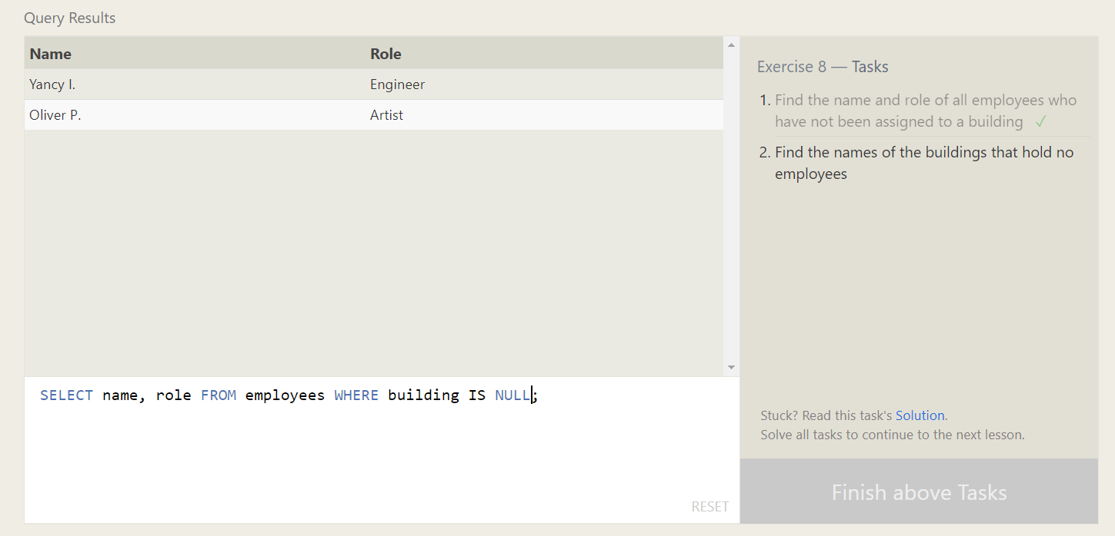

Find the names of the buildings that hold no employees

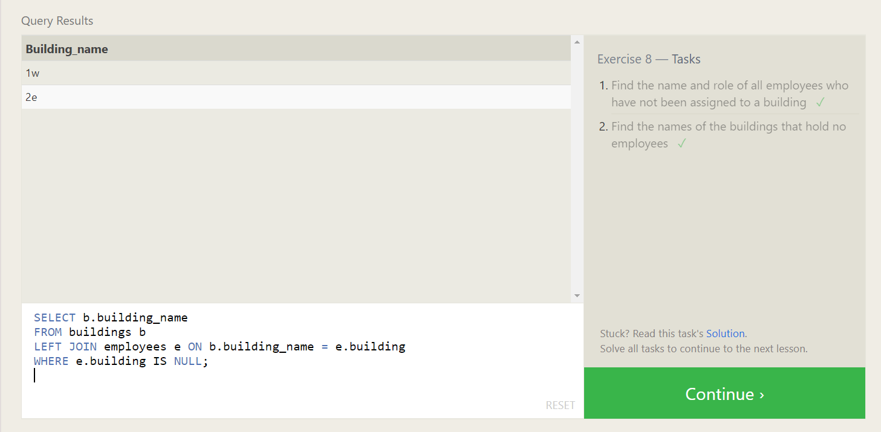

List all movies and their combined sales in **millions** of dollars

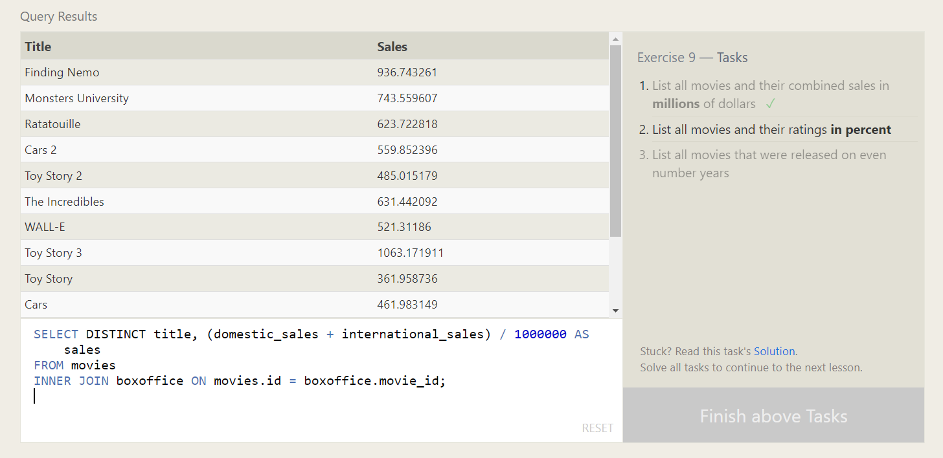

List all movies and their ratings **in percent**

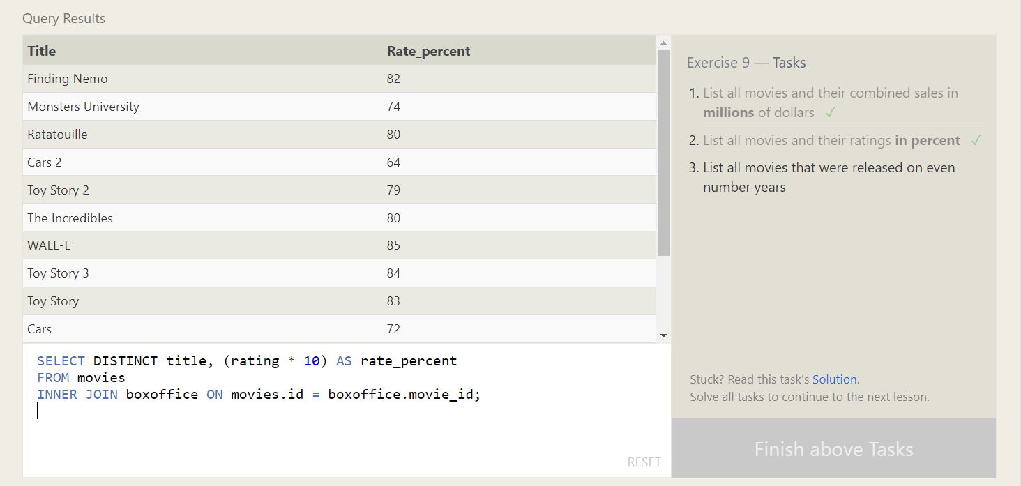

List all movies that were released on even number years

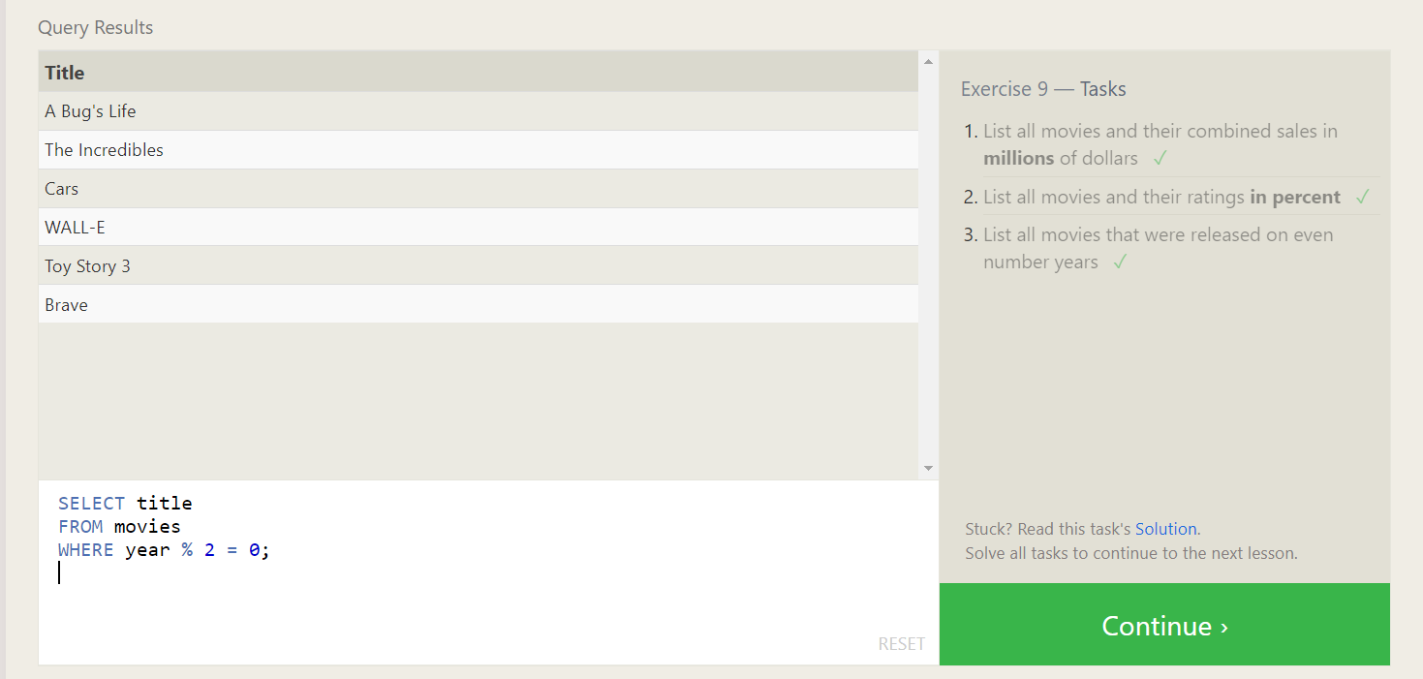

Find the longest time that an employee has been at the studio

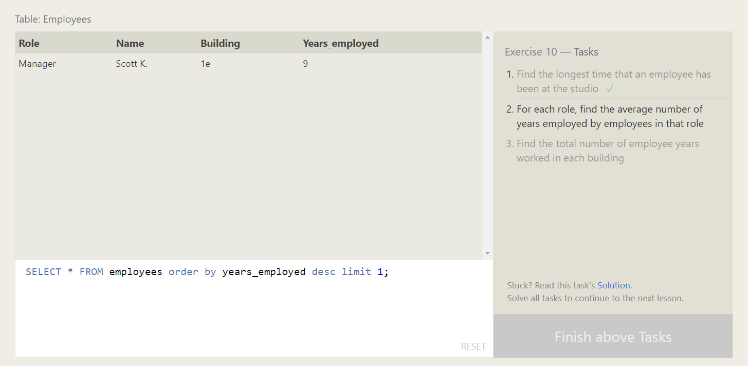

For each role, find the average number of years employed by employees in that role

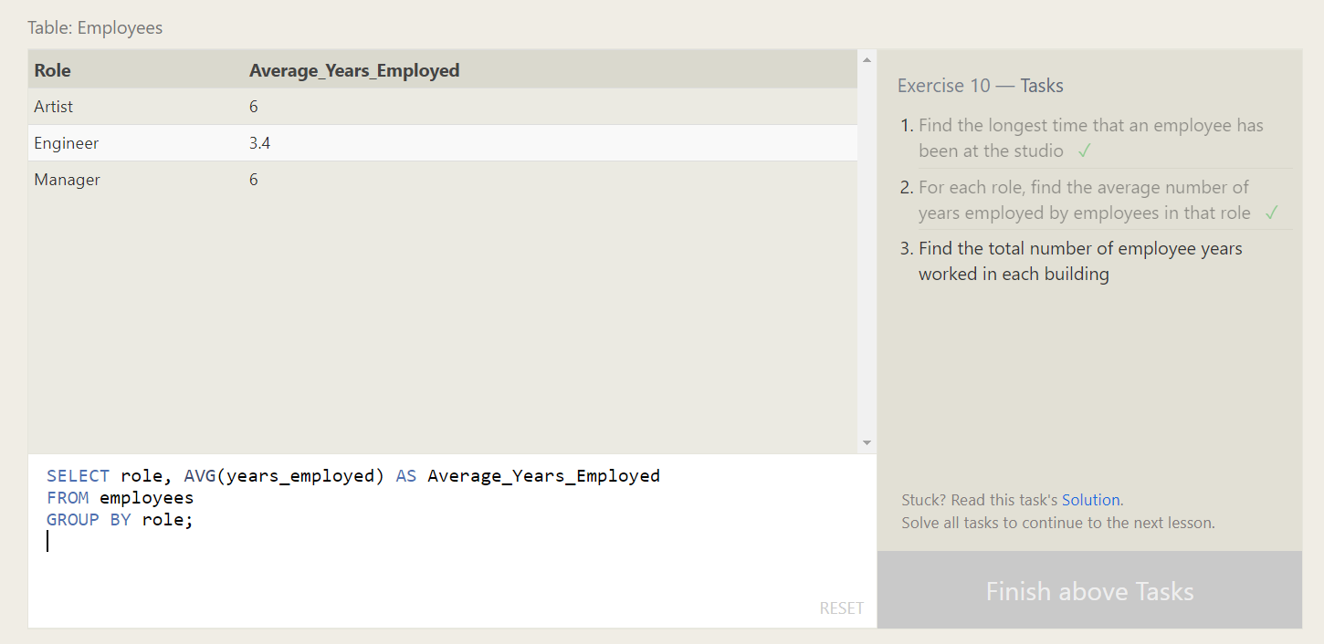

Find the total number of employee years worked in each building

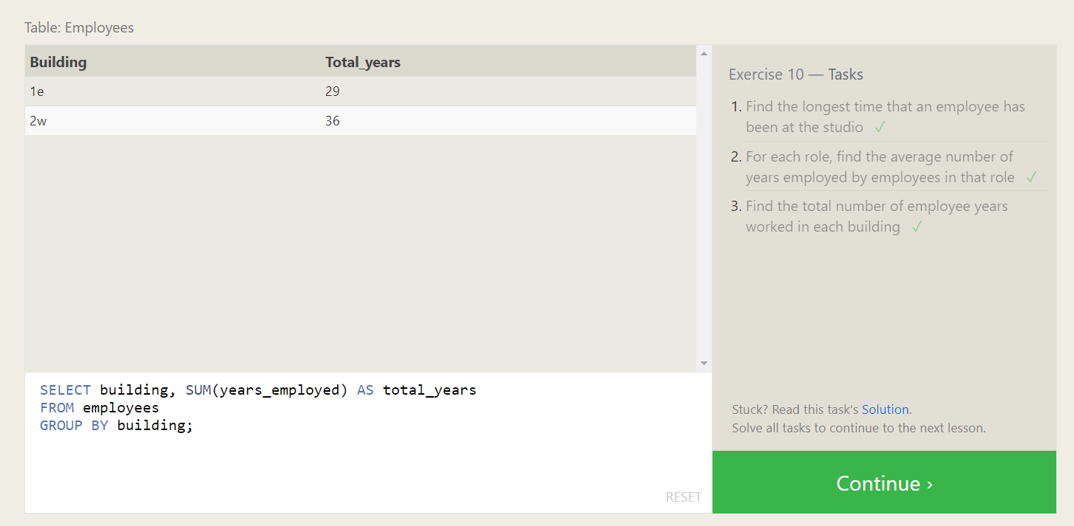

Find the number of Artists in the studio (without a **HAVING** clause)

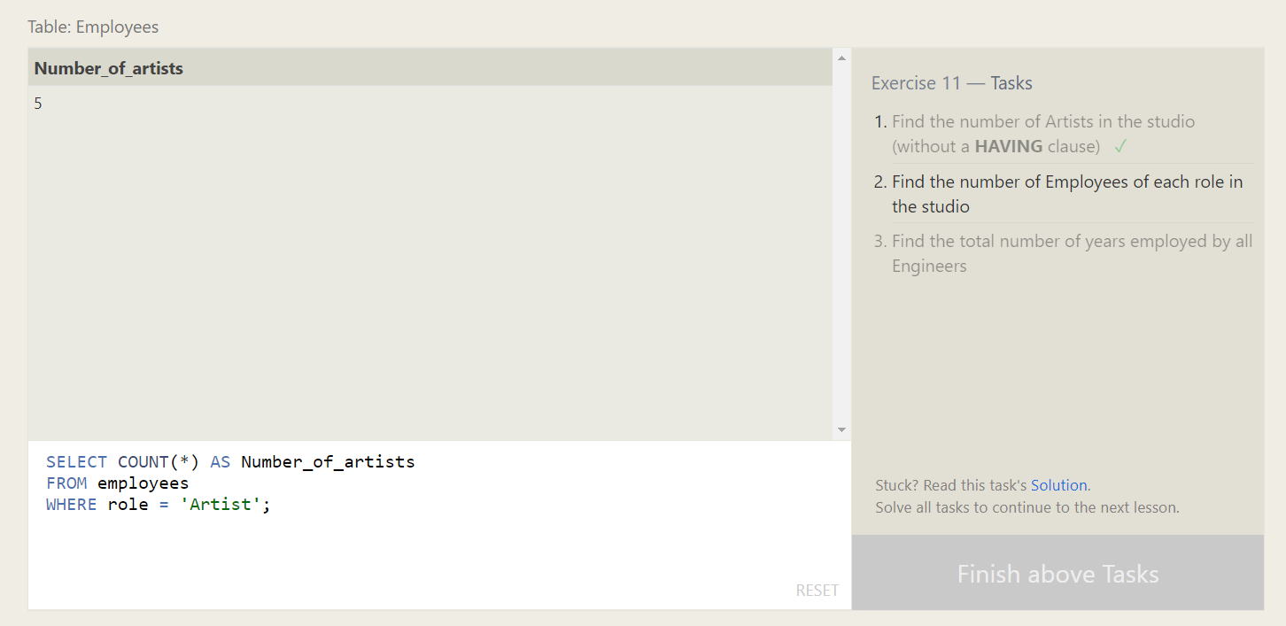

Find the number of Employees of each role in the studio

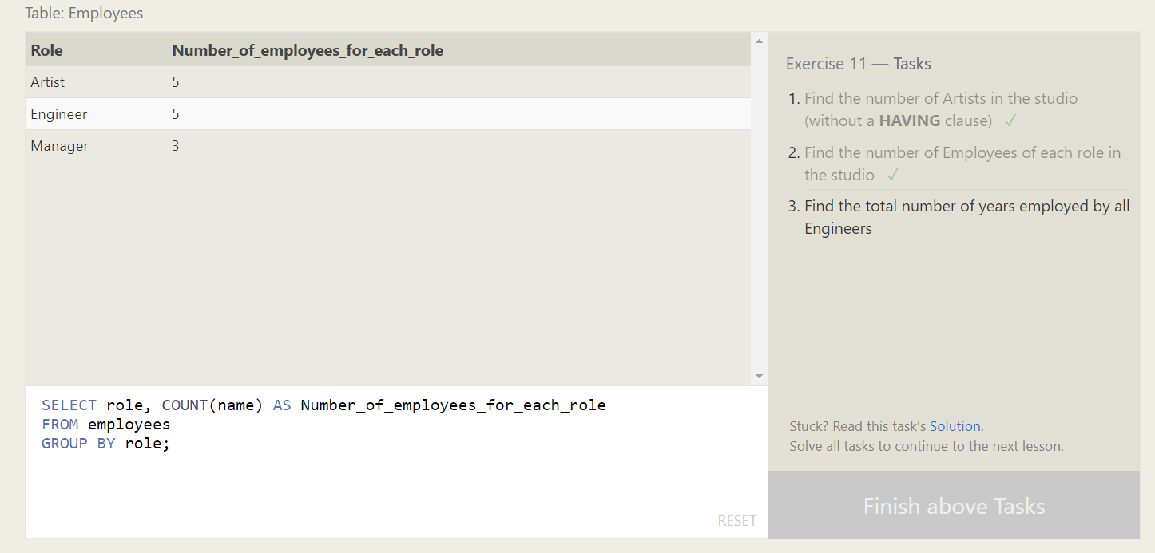

Find the total number of years employed by all Engineers

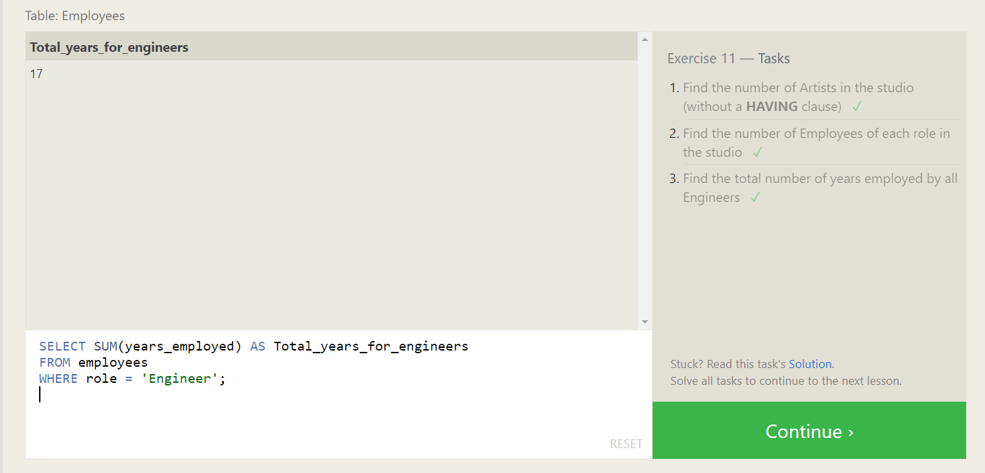

Find the number of movies each director has directed

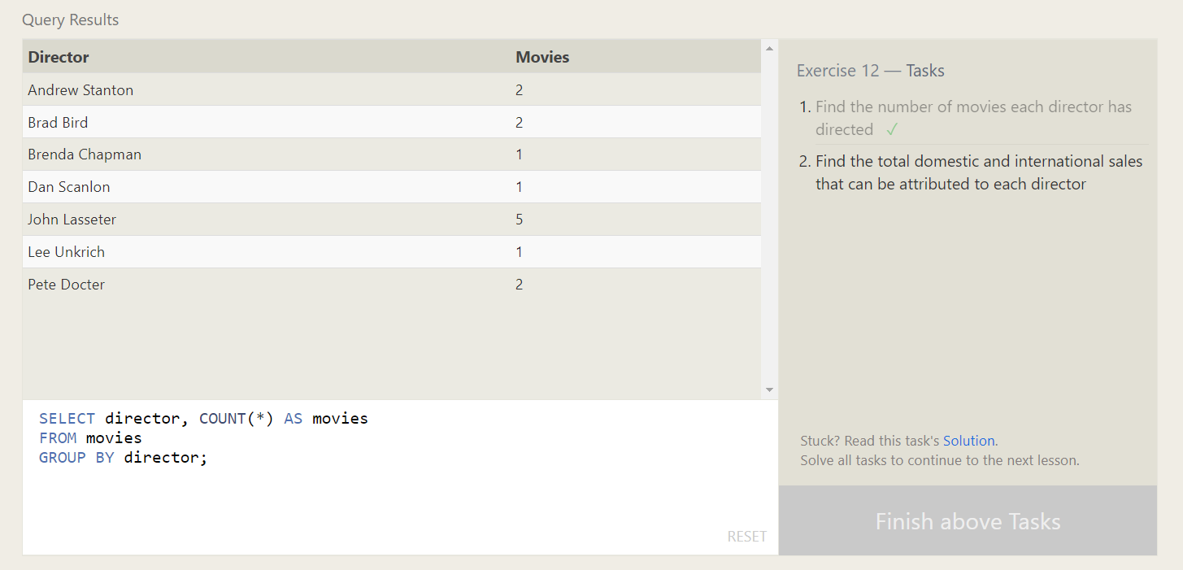

Find the total domestic and international sales that can be attributed to each director

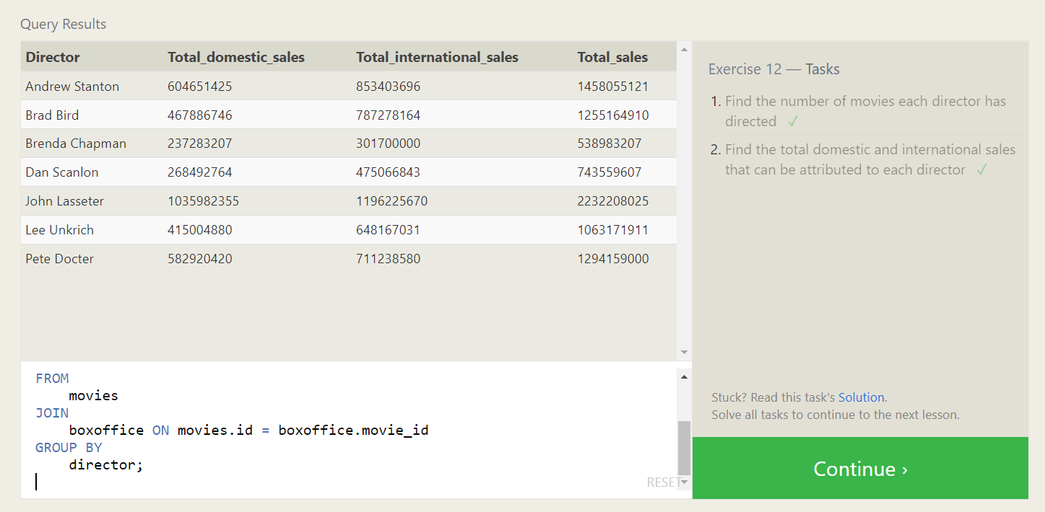

Insert value into movies table.

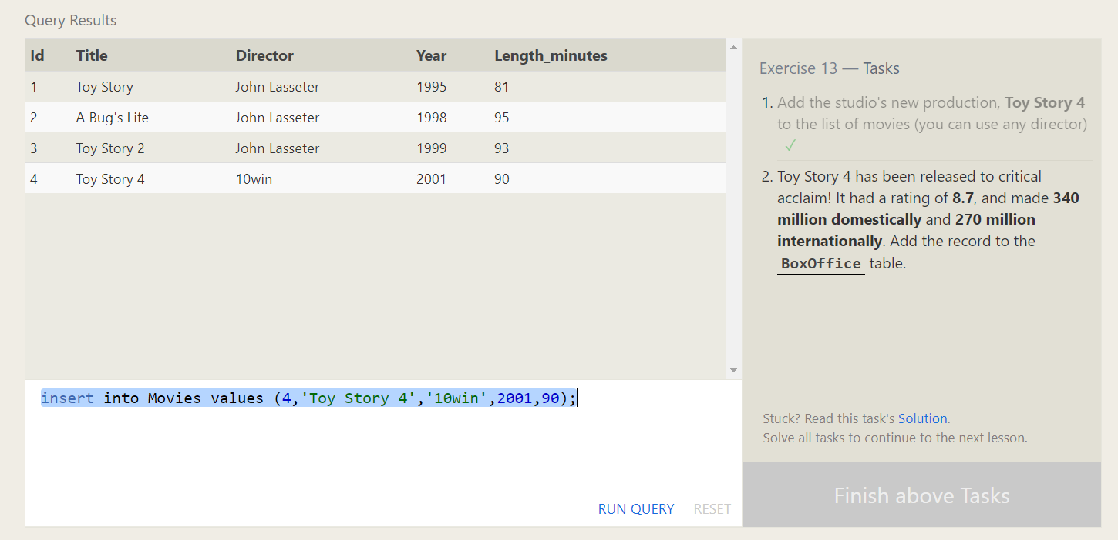

Insert value into box office table.

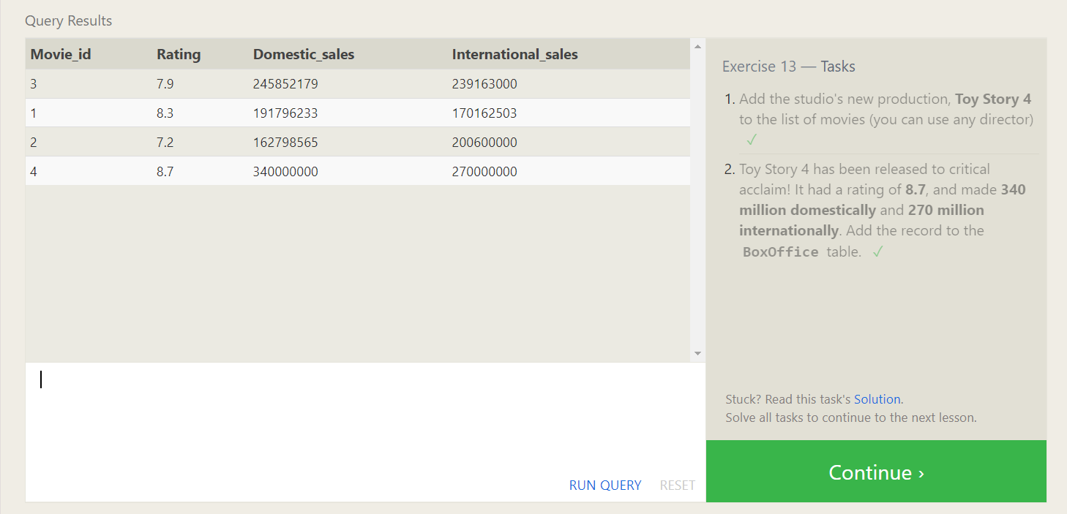

The director for A Bug's Life is incorrect, it was actually directed by **John Lasseter**

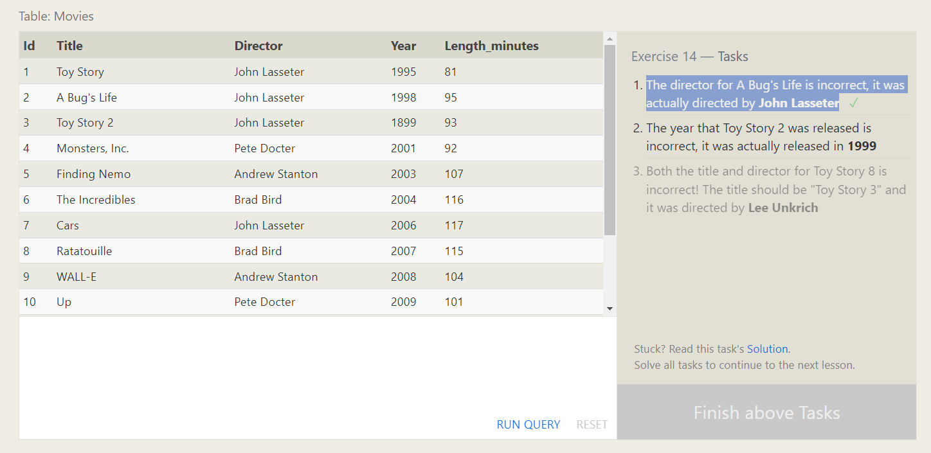

The year that Toy Story 2 was released is incorrect, it was actually released in **1999**

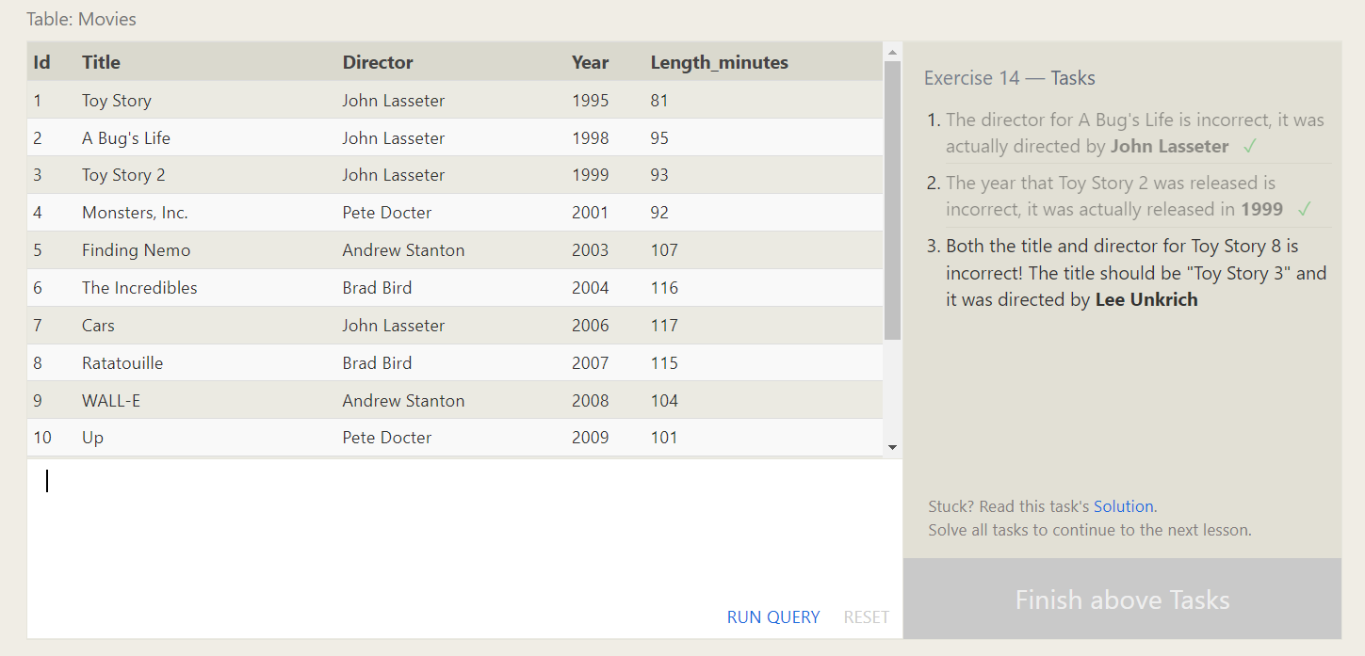

Both the title and director for Toy Story 8 is incorrect! The title should be "Toy Story 3" and it was directed by **Lee Unkrich**

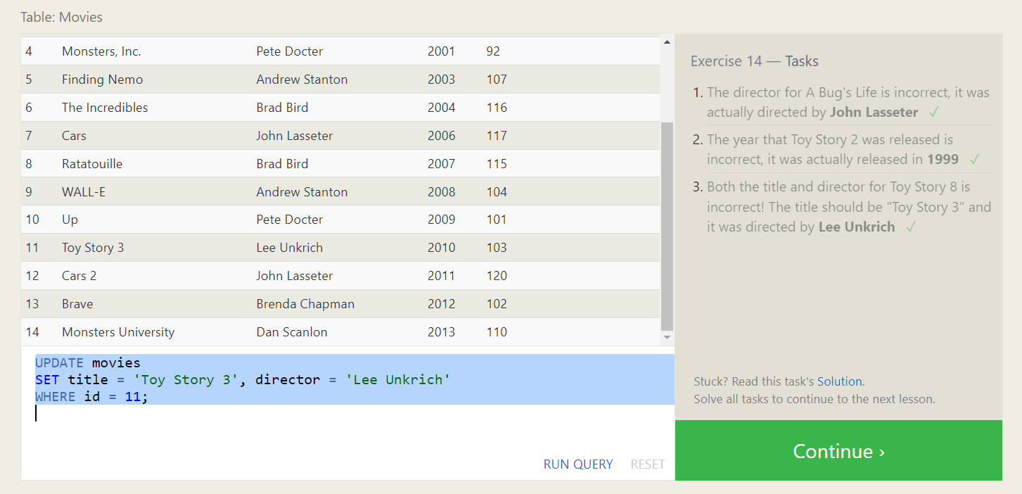

Delete movies released before 2005.

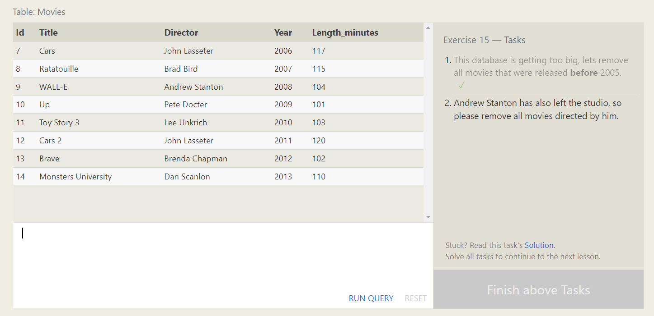

Andrew Stanton has also left the studio, so please remove all movies directed by him.

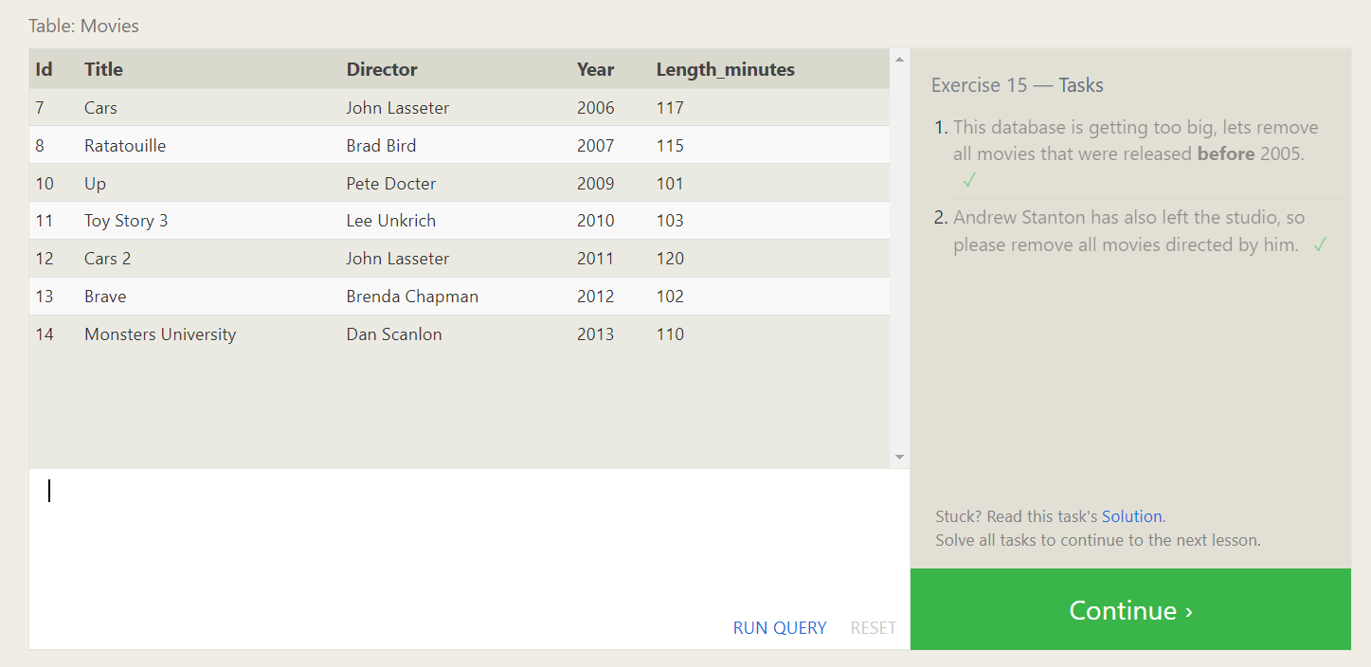

Create a new table named **Database** with the following columns:

– **Name** A string (text) describing the name of the database  
– **Version** A number (floating point) of the latest version of this database  
– **Download_count** An integer count of the number of times this database was downloaded

This table has no constraints.

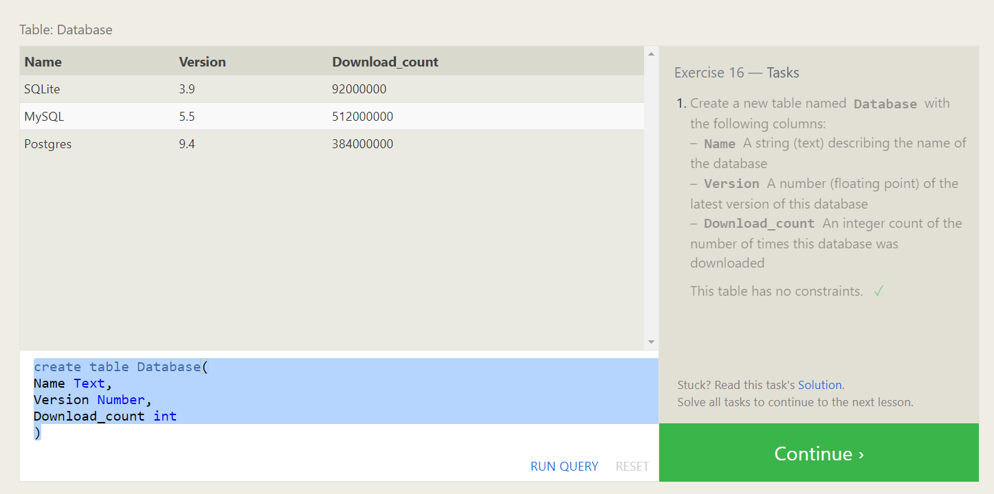

Add a column named **Aspect_ratio** with a **FLOAT** data type to store the aspect-ratio each movie was released in.

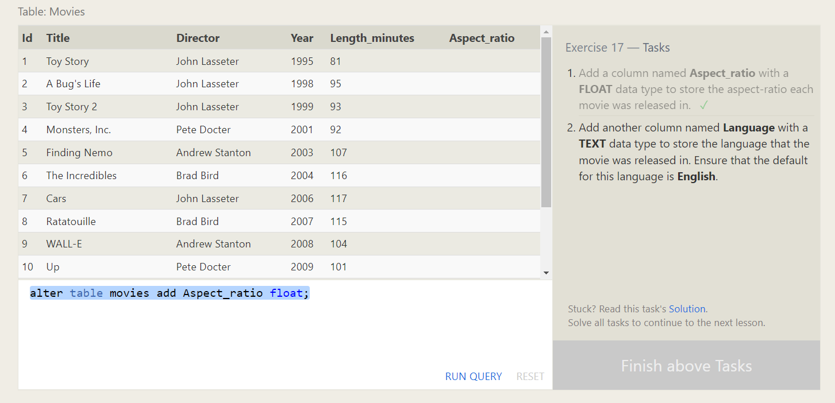

Add another column named **Language** with a **TEXT** data type to store the language that the movie was released in. Ensure that the default for this language is **English**.

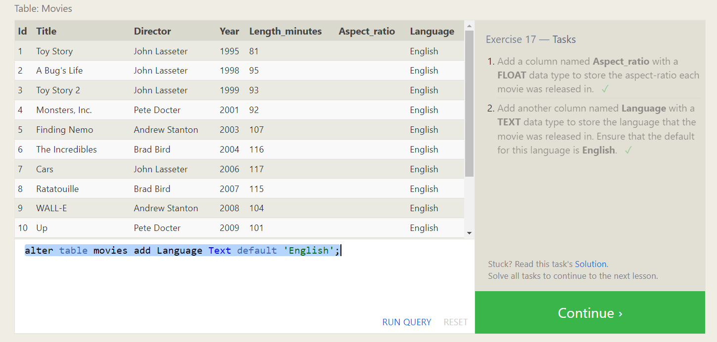

Drop table movies.

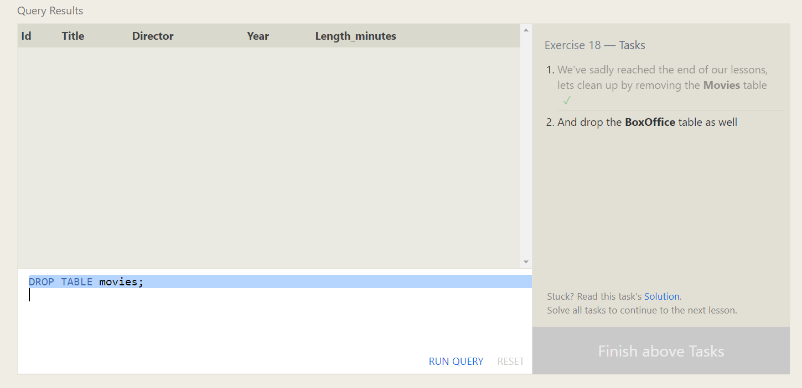

Drop box office movies.

